07P: 249 Factor Analysis and Structural Equation Models
Dr. Dunbar
Course Project
Huijuan Meng
05/12/2005

Hierarchical Model of Human Intelligence Factors on 37 Ability Tests

A Replication Approach via Schmid-Leiman Technique

I. Introduction:
In this project, correlation matrix of 37 cognitive ability tests in high school sample (N=241) has been analyzed via confirmatory factory analysis in LISREL and exploratory factor analysis in SAS and SPSS.

The original goal is to replicate the orthogonal hierarchical matrix presented in Marshalek, Lohman & Snow 1983 article. Due to the limitation of computational capability at that time, in that article, instead of employing more sophisticated factor extraction methods (e.g. MLE, ULS, and ALPHA) and techniques such as Schmid-Leiman procedures, the multiple group factor and Wherry technique were used to derive the hierarchical intelligence factor model.

In that model, at the bottom, there are 9 first order factors: Closure Speed (CS), Spatial Relations (SR), Perceptual Speed (PS), Reasoning with Symbols (RS), Numerical Skills (NS), Verbal Comprehension (VC), Reading Comprehension (RC), Language Skill (LS), and Memory Span (MS). These endogenous latent variables were hypothesized to directly affect how people perform on the 37 ability tests. In the middle, 3 second-order, broader intelligence factors: Visualization (GV), Quantitative (GQ), and Verbal (GC), subsume the first-order factors mentioned above. And on the top, the third-order factor, General Intelligence (GI), is assume to be an exogenous latent variable exerting effect on the second-order factors.

Twenty-two years passed, and facing this complex factor model, we wonder whether or not we can get at least the similar factor loading structure for these ability tests, had modern methods and techniques had been used. This is the rationale for doing this project.

II. Literature Review
(1) Human Intelligence Model: Hierarchical models have been seemed to provide the most promising and parsimonious way to think about mental ability factors (Marshalek, et, al 1983) and the broad general factor (General ability) accounts for performance in various intelligence tests. Tests that correlate highly with this factor are “complex” tests, requiring abstract problem-solving analysis and rule inferring. Schmid-Leiman solution for hierarchical factor model is believed (Wolff & Preising, 2005) to have a few advantages over traditional higher-order factor model. First, difficulties in interpretation and labeling of factors may be reduced by calculating direct relations between variables and higher-order factors. Second, this solution separates the total contribution of factors to variables into nonoverlapping elements. This provides information about the independent contribution of first-order and higher-order factors to variables. Therefore, it facilitates interpretation by clearly showing each factor’s unique influence on variables. Since we want to understand how General Intelligence factor, second-order factors, and those much narrower third-order factors affect the 37 cognitive ability tests respectively, Schmid-Leiman technique is chosen to produce the factor loadings.

(2) Schmid-Leiman Transformation: Schmid-Leiman technique is used to transform an oblique factor analysis solution containing a hierarchy of higher-order factors into an orthogonal solution. Factor loading matrices resulting from higher-order FA are transformed to provide independent loadings of variables on factors of all levels. The procedures are described in Schmid and Leiman (1957) as the following:
- A correlation matrix, R, is decomposed into correlated common factors and unique factor. R=F₁R₁F₁’+U₁², F₁: 1st order factor pattern matrix; R₁: 1st order factor correlation matrix; U₁²: unique variances of variables;
- The 1st order factor correlation matrix: R₁ is further decomposed as: R₁=F₂R₂F₂’+U₂²; and interpretation of this formula is the same as the one in step a;
- Each higher-level matrix of intercorrelations among primary factors is decomposed in this fashion until R_{i} becomes the identity matrix, that is,
R_{i-1}=F_{i}F_{i}’+U_{i}² (In our case, we ends with R₂= F₃F₃’+U₃²).
- To obtain the Schmid-Leiman solution, further calculations are necessary. First, we need to form matrix B₃,by appending U₃ to F₃: B₃=[F₃:U₃] — R₂ (with communalities)= F₃F₃’; R₂ (with unities)= B₃B₃’; then, we multiply F₂ by B₃. Next, we get B₂, and B₂ = [F₂*B₃:U₂]; R₁ (with communalities) = F₂ B₃* B₃’F₂’; R1 (with unities) = B₂* B₂’, and finally, the hierarchical solution, B=F₁* B₂, and R (with communalities) = BB’
- To determine the impact of a factor, the sum of its squared loadings can be calculated. To obtain the contribution of all factors of a particular level, these may be summed over all factors of this level. Standardization of these indices by the total sum of variance explained yields the percentage of variance explained by a factor or factor level respectively.

According to these procedures, Wolff and Preising (2005) have written syntax in SAS and SPSS for Schmid-Leiman transformation. Their syntax is used to derive the solution after obtaining F_{1,} F_{2,} and F₃ matrices from either EFA or CFA. And the results have been checked to make sure they followed the formula presented above.
III. Approaches:
- LISREL: Confirmatory Factor Analysis Approach: In this project, the model is derived according to intelligence theories and targeted model in the article; therefore, LISREL was chosen to conduct Confirmatory Factor Analysis.
Although a Schmid-Leiman hierarchical model (Figure 1) is argued to yield clear interpretation of the factor effect on variables, in this project, however, the model specification still follow a traditional higher-order factor model format (Figure 2) because the former model identification may not be accepted by LISREL. Since the proportionality constraints have not been found in Schmid-Leiman solution, this model can be viewed as an equivalent model to the hierarchical factor model (Yung, Thissen, and McLeod, 1999).

Figure 1: A Schmid-Leiman Hiearchical Factor Model | Figure 2: A Traditional Higher-Order Factor Model
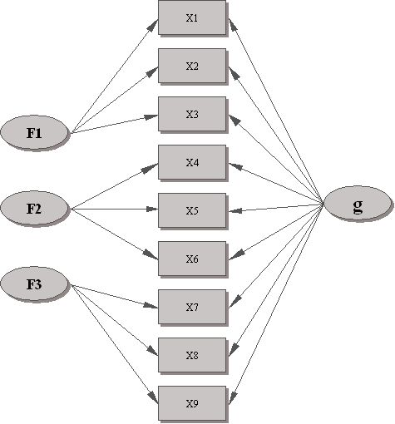 | 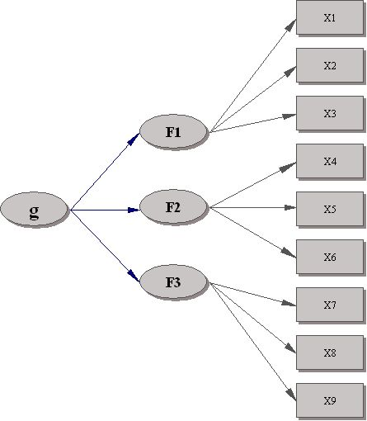
- Model Specification (1): Factor loading pattern in Marshalek, Lohman & Snow article has been examined, and according to their work, the hierarchical factor structure has been proposed, and further inspected by Dr. Lohman for its accuracy. In this model, the 3rd order factor GI is the only exogenous latent variable; 2nd and 1st order factors (12 in total) are the endogenous latent variables, 36 Y variables, and 1 X variable (WAIS Picture Arrangement test was believed to be accounted only by the General Intelligence factor). Since the 2nd order factor do not have any indicator variables (See Figure 3), when running this model, LISREL warns that LAMBDA-Y does not have full column rank.

Figure 3: Path Diagram for Model 1
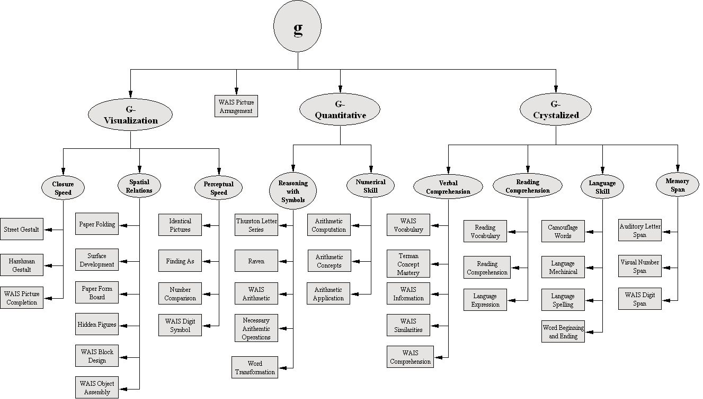

- Model Specification (2): Because of the problem aforementioned, the model has been modified as the following: the 3rd order and 2nd order factors (4 in total) are treated as 4 correlated exogenous latent variables; and 3 of them (2nd order) exert effect on 9 1st order endogenous latent variables, which, as before, affect 36 Y variables, and the 4th exogenous factor affects only one X variable (See Figure 4). It is hoped that this kind of arrangement would correct the non-full column rank LAMBDA-Y issue. This time, unfortunately, the LAMBDA-X does not have the full column rank.

Figure 4: Path Diagram for Model 2
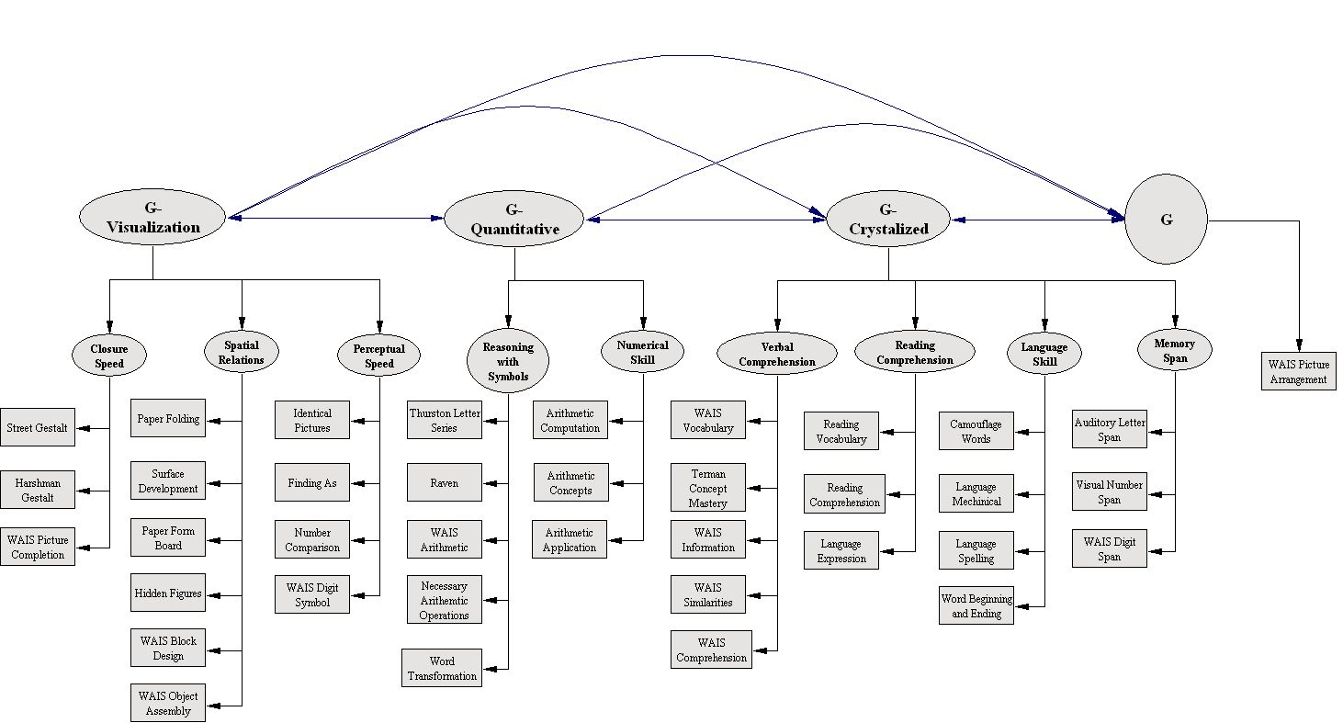
- Model Specification (3): From above trials, it has been realized that this 3-order hierarchical model might not be solved directly in LISREL, and an alternative, step-by-step approach may be more appropriate in this case, that is: first fit the 9 first-order factors model to the data; then fit 3 second-order factors to the first-order factor correlation matrix; and finally, fit 1 third-order factor to the second-order factor correlation matrix. As a result, the model has been simplified to the first order factor model in which 9 exogenous latent variables are hypothesized to affect 37 intelligence tests.
In output file, LISREL indicated that the 9-factor correlation matrix, Phi (), is not positive definite. According to the messages posted on the SEMNET, whenever we see a "Phi is not positive definite" warning, we have a factor correlation that is too close to +/- 1. In other words, the data suggest fewer factors in the model than we hypothesized. Back to the 9 first-order factor LISREL output, this explanation is verified in this case—a 0.98 correlation is found in the Phi matrix. And when the number of first-order factor is reduced to 7, LISREL yields a positive definite phi.

Suspecting that the underlying model is questionable, exploratory factor analysis is suggested to be used to thoroughly examine the data. In LISREL, however, the command NF=<number> is no longer effective to exact number of factors specified in the model, and the LISREL Exploratory Factor Analysis tutorial only demonstrates how to conduct EFA with raw data. I tried various ways to exact 9 factors, and they either failed or did not yield interpretable results. In this circumstance, SAS and SPSS have been used instead.

- SAS/SPSS Exploratory Factor Analysis Approach
In order to obtain more reliable result, 4 factor exaction methods: MLE, ULS, ALPHA, and GLS (only available in SPSS) have been employed to extract 9 first-order factors using maximum absolute correlation value as initial communality estimate. PROMAX rotation method has been used to get pattern structure matrix with Kappa (Power) value 4 (this value affects pattern matrix differently for different method; whenever coefficient in pattern matrix >1, smaller power value 3 is used). SAS and SPSS produced almost identical results for all the methods being examined, and very similar pattern was found for MLE and ULS. Various combinations of the numbers of factors have been tested via different methods. The results are summarized in the table below.

Table 1: SAS Exploratory Factor Analysis Results
FACTOR COMBINATION | MLE | ULS | ALPHA
10-4-1 | No Heywood Case;  No strange pattern. | No Heywood Case;  No strange pattern. | In 1st order, one factor is negatively correlated with all other factors;  3rd order: Heywood case
10-3-1 | Heywood Case in 2nd and 3rd order EFA | Heywood Case in 2nd order EFA | In 1st order, one factor is negatively correlated with all other factors;
9-4-1 | No Heywood Case;  No strange pattern. | No Heywood Case;  No strange pattern. | In all orders: one factor is negatively correlated with all other factors;
9-3-1 | Heywood Case in  2nd and 3rd order EFA | Heywood Case in  2nd and 3rd order EFA | In 1st order, one factor is negatively correlated with all other factors;
8-3-1 | Heywood Case in  2nd and 3rd order EFA | Heywood Case in  3rd order EFA | Heywood Case in  3rd order EFA
7-3-1 | Heywood Case in  2nd and 3rd order EFA | Heywood Case in  2nd order EFA | No Heywood Case;  No strange pattern.
  - 10-4-1 means 10 first-order factors, 4 second-order factors, and 1 third-order factor, same interpretation for others in the first column.
From these trials, it seems that ALPHA method is the least sensitive to Heywood case at the price of forcing one factor negatively correlated with other factors; whereas for MLE and ULS, only combinations of 9-4-1 or 10-4-1 factor structure are free of Heywood case.

In order to find an acceptable model, Schmid-Leiman transformation has been conducted for models which are free of Heywood case; and the results have been compared to the one presented in the article. It was found that the outcomes are consistently unsatisfying across all the models being tested.

First, the transformation is unable to separate 3 hypothesized 2nd order factors (See Appendix 1 for details): Visualization and Quantitative factor loaded tests cluster together, and same thing happens to Quantitative and Verbal factor loaded tests.

Second, in the matrix, Perceptual Speed factor shows twice (in the 1st and 2nd order). This is not surprising since this factor “did not cluster neatly with any of these second-order clusters” (p.116, Marshalek, et al). In EFA, computer specifies everything, and we can’t manually maneuver the factor-test relationship. As a result, this singleton appears on both levels.

Third, the transformation did NOT produce clear boundaries among factors as what have been shown in the article. Verbal Comprehension and Reading Comprehension factor loaded tests, Numerical Skill and Reasoning with Symbols factor loaded tests, and Closure Speed and Spatial Relations factor loaded tests are grouped together. But Reading Comprehension and Closure Speed factor, probably so powerful that tests under these 2 factors form 2 independent clusters again. Only the Memory Span and Language Skill factor affect the test in the same way as they did in the article matrix.

The departure of the results from the targeted matrix indicates that the EFA is not appropriate for forming such a complex model, at least in this case. However, the pattern matrix for the 1st order factors (See Appendix 2 for reference) does suggest some model modifications (the numbers in the parentheses are the coefficients in the pattern matrix for the 1st order factors produced in SAS, MLE):

  - WAIS Picture Completion, originally being classified as a test under Closure Speed factor (0.11), should be moved under Spatial Relations factor (0.31).
  - Raven, instead of being affected by Perceptual Speed factor (0.18), is specified as a Spatial Relations factor loaded test (0.58).
  - WAIS Picture Arrangement, previously not linked to any 1st and 2nd order factor, is now being associated with Spatial Relations factor (0.28).
  - Word Transformation is moved from Reasoning with Symbol factor (0.03) to Language Skill factor (0.42).
  - Language Mechanical, in the article, has a Perceptual Speed factor loading as 0.12, which is contradictory with the MLE result—in MLE pattern matrix, the Perceptual Speed factor loading for this test is -0.12. And Numerical Skill factor loading for this test has been added (0.39).
  - Tests under Numerical Skill and Reasoning with Symbols factor are classified under only one factor. Meanwhile, Thurston Letter Series, Raven, and WAIS Block Design are clustered together under one unknown factor (probably a visual reasoning ability factor).
  - Tests under Verbal Comprehension (VC) and Reading Comprehension (RC) factor are specified under the VC factor, but the subset of these tests is specified under RC factor one more time.

In summary, comparing with previous LISREL models, in which one test is affected by only one factor; modified model is more flexible and realistic: multiple factors are specified for 18 tests. This action is justified not only by the EFA results, but also by the article, where the Orthogonal Hierarchical matrix shows the similar pattern (However, modifications aforementioned have to be done: the solution for the model that exactly followed article matrix specifications was found non-admissible after 100 iterations. The reason for I did not include these minor loading coefficients shown in the article matrix at the initial model specification stage is because I incorrectly thought they were caused by the sampling error since the sample size is only 241, quite small for this complicated model— the ratio of cases to free parameters is much less than 10:1 (Kline, P. 178, 2005).

- LISREL Continuous: Confirmatory Factor Analysis Approach
- Model Specification (4): This model is specified according to the EFA results, the article matrix, and the LISREL Modification Index. Now it is more complicated than previous ones but with fewer restrictions. For the 1st order, the number of estimated parameters increases from 37 to 76—more complex tests such as Raven, Necessary Arithmetic Operations, and Thurstone Letter Series are now specified as being affected by 3 or 4 factors; whereas simple tests such as Harshman Gestalt, Street Gestalt, and WAIS Digit Span are specified as being affected by only 1 factor. Then the correlation matrix of the 1st order and the 2nd order factors (9x9 and 3x3 respectively) are analyzed in LISREL separately. After CFA has been completed for all three order factors, estimated parameters are entered in the overall model (even with “LAMBDA-Y does not have full column rank” warning).
- Results and Model Evaluation:
  - First Order Factor model:
    - Degrees of Freedom = 554
- Minimum Fit Function Chi-Square = 794.83 (P =0.00 )
- Root Mean Square Error of Approximation (RMSEA) = 0.037
- Root Mean Square Residual (RMR) = 0.038
- Goodness of Fit Index (GFI) = 0.86
- Normed Fit Index (NFI) = 0.87
- Non-Normed Fit Index (NNFI) = 0.95
- Comparative Fit Index (CFI) = 0.96
Figure 5: Path Diagraph for the First-Order Factor Model
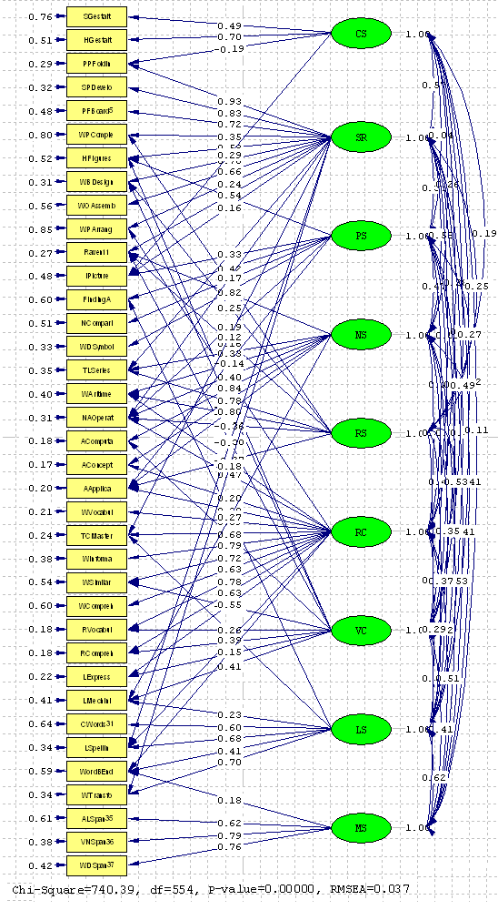
Table 2: LISREL Result: First-Order Factor Loading (F₁)
First-order Pattern Matrix | CS | SR | PS | RS | VC | RC | LS | MS | RS
Street_Gestalt | 0.49
Harshman_Gestalt | 0.7
Paper_Folding | -0.19 | 0.93
Surface_Development |  | 0.83
Paper_Form_Board |  | 0.72
WAIS_Picture_Completion |  | 0.35 |  |  |  |  |  |  | 0.21
Hidden_Figures |  | 0.58 | 0.15 |  |  | 0.12
WAIS_Block_Design |  | 0.78 |  |  |  | -0.26 |  |  | 0.25
WAIS_Object_Assembly |  | 0.66
WAIS_Picture_Arrangement |  | 0.24 |  |  | 0.2
Raven |  | 0.54 |  | 0.21 |  | 0.22 |  |  | 0.16
Identical_Pictures | 0.29 | 0.16 | 0.54
Finding_As |  |  | 0.42 |  |  |  | 0.3
Number_Comparison |  |  | 0.7
WAIS_Digit_Symbol |  |  | 0.82
Thurstone_Letter_Series |  | 0.33 |  | 0.33 |  |  |  |  | 0.36
WAIS_Arithmetic |  |  |  | 0.45 | 0.6 |  |  |  | -0.41
Necessary_Arithmetic_Operations |  | 0.17 | 0.19 | 0.4 | 0.47 |  |  |  | -0.36
Arithmetic_Computation |  |  |  | 0.84 |  | 0.13
Arithmetic_Concepts |  |  |  | 0.78 | 0.2
Arithmetic_Application |  |  | -0.14 | 0.8 | 0.38 |  |  |  | -0.27
WAIS_Vocabulary |  |  |  |  | 0.89
Terman_Concept_Mastery |  | 0.12 |  |  | 0.68 |  | 0.16
WAIS_Information |  |  |  |  | 0.79
WAIS_Similarities |  |  |  |  | 0.72 | -0.19
WAIS_Comprehension |  |  |  |  | 0.63
Reading_Vocabulary |  |  |  |  | 0.78 | 0.26
Reading_Comprehension |  |  |  |  | 0.63 | 0.47
Language_Expression |  |  |  |  | 0.55 | 0.52
Language_Mechinical |  |  |  | 0.27 |  | 0.41 | 0.23
Camouflage_Words |  |  |  |  |  |  | 0.6
Language_Spelling |  | -0.38 |  |  | 0.39 |  | 0.68
Word_Beginning_Ending |  |  |  |  | 0.15 |  | 0.41 | 0.18
Word_Transformations |  | 0.18 |  |  |  |  | 0.7
Auditory_Letter_Span |  |  |  |  |  |  |  | 0.62
Visual_Number_Span |  |  |  |  |  |  |  | 0.79
WAIS_Digit_Span |  |  |  |  |  |  |  | 0.76

Figure 6: Summary Statistics for Fitted Residuals
(1) Stem-leaf of Standardized Residuals
- 2|987755
- 2|444433333322221111000000
- 1|999999998888887777777766666555555
- 1|4444444444443333333332222222222222111111111000000000000
- 0|999999999999999999888888888888888888888877777777777777777777666666666666+33
- 0|444444444444333333333333333333333333333222222222222222222222222221111111+84
0|111111111111111111111112222222222333333333333333333333333333334444444444+08
0|555555555555555555555555555555566666666666666666677777777777777777778888+34
1|000000000000000111111111111111122222222222222233333333333334444444444
1|55555555555566666667777777778888888899999999
2|0001112233344
2|566678899
3|023
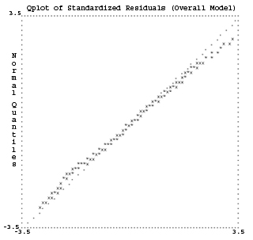

Goodness-of-fit statistics: The results of first-order factor model, although not satisfying (GFI=0.86, NFI=0.87), probably is the best I can get under the theory constrains. The Root Mean Square Error of Approximation is 0.037, and Root Mean Square Residual is 0.038. Both of them are below the benchmark value 0.05. Besides, the Comparative Fit Index is 0.96, which is larger than 0.90, and indicates an acceptable fit to the data. Although it still can be improved by adding more free parameters, but statistics index should be used with theoretical justifications. For example, according to the modification indices, including 8 additional free LXs would decrease the overall chi-square value by about 48, but I did not add these parameters since the article results and the theories don’t show evidence for such action.

Residual statistics: First, the stem-leaf shows that the standardized residuals are symmetrically clustered around the zero point, with most being in the middle of the distribution and only a few in the tails, which, according to Jöreskog, characterizes a well-fitted model. Second, in the Q-plot, the residuals, roughly speaking, follow the 45-degree angle dotted line, which also indicates a well-fitting model. Third, it was found that complex and quantitative tests are poorly modeled. LISREL lists 15 largest standardized residuals, 11 of them involves Terman Concept Mastery, Thurstone Letter Series, Necessary Arithmetic Operations, WAIS Arithmetic, and Arithmetic Application. So how to fit these tests should be investigated in further study.

Factor Correlation Matrix Analysis: The correlations among 9 first-order factors were examined, and most of them are consistent with theories. For example, factor Verbal Comprehension, Reading Comprehension, Memory Span, are correlated with Language Skills factor with the highest coefficient. Spatial Relationship is highly correlated with another visualization factor, Closure Speed. But two quantitative factors, Numerical Skills and Reasoning with Symbols (this one is questionable) don’t yield the highest correlation. Numerical Skills and Spatial Relationship produces the highest correlation, whereas Reasoning with Symbols and Reading Comprehension yield the highest correlation. This, to some extent, corroborates the residual analysis result.

Table 3: LISREL Result: First-Order Factor Correlation Matrix
PHI | CS | SR | PS | NS | RC | VC | LS | MS | RS
Factor1: Closure Speed | 1
Factor2: Spatial Relationship | 0.57 | 1
Factor3: Perceptual Speed | 0.04 | 0.34 | 1
Factor4: Numerical Skills | 0.26 | 0.58 | 0.47 | 1
Factor5: Verbal Comprehension | 0.28 | 0.52 | 0.23 | 0.58 | 1
Factor6: Reading Comprehension | 0.08 | 0.23 | 0.37 | 0.45 | 0.35 | 1
Factor7: Language Skills | 0.32 | 0.54 | 0.55 | 0.63 | 0.62 | 0.57 | 1
Factor8: Memory Span | 0.11 | 0.41 | 0.41 | 0.53 | 0.51 | 0.41 | 0.62 | 1
Factor9: Reasoning with Symbols (?) | 0.19 | 0.25 | 0.27 | 0.49 | 0.53 | 0.35 | 0.37 | 0.29 | 1

  - Second Order factor model:
    - Degrees of Freedom = 24
    - Minimum Fit Function Chi-Square = 183.37 (P = 0.0)
    - Root Mean Square Error of Approximation (RMSEA) = 0.16
    - Root Mean Square Residual (RMR) = 0.1
    - Goodness of Fit Index (GFI) = 0.87
    - Normed Fit Index (NFI) = 0.81
    - Non-Normed Fit Index (NNFI) = 0.75
    - Comparative Fit Index (CFI) = 0.83

Figure 7: Path Diagraph for the Second-Order Factor Model

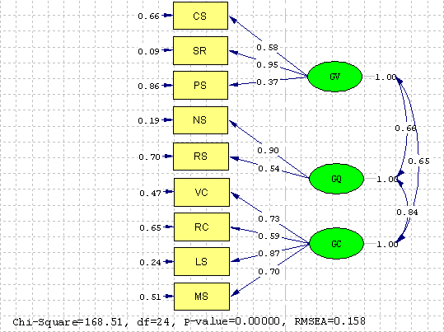

Table 4: LISREL Result: Second-Order Factor Loading (F₂)
Second-order factor loadings | G-Visualization | G-Quantitative | G-Verbal
Factor1: Closure Speed | 0.58
Factor2: Spatial Relationship | 0.95
Factor3: Perceptual Speed | 0.37
Factor4: Numerical Skills |  | 0.9
Factor5: Verbal Comprehension |  |  | 0.73
Factor6: Reading Comprehension |  |  | 0.59
Factor7: Language Skills |  |  | 0.87
Factor8: Memory Span |  |  | 0.7
Factor9: Reasoning with Symbols |  | 0.54

Table 5: LISREL Result: Second-Order Factor Correlation
 | G-Visualization | G-Quantitative | G-Verbal
G-Visualization | 1
G-Quantitative | 0.66 | 1
G-Verbal | 0.65 | 0.84 | 1

The model fit statistics results for second-order factor model are extremely unsatisfying. These indices can be dramatically improved if we allow multiple factor structure. The indices below show the results after we allow more than one 2nd order factors to load on the 1st order factor.
- Degrees of Freedom = 19
- Root Mean Square Error of Approximation (RMSEA) = 0.12
- Root Mean Square Residual (RMR) = 0.048
- Goodness of Fit Index (GFI) = 0.93
- Normed Fit Index (NFI) = 0.90
- Non-Normed Fit Index (NNFI) = 0.85
- Comparative Fit Index (CFI) = 0.92

Although this modification does improve the model fit for this level, the fitness of overall model is worse than the one that does not allow more than one 2nd order factor to load on the 1st order factor. Therefore, this model is abandoned for now, but may be explored later.

  - Third Order model: The Model is saturated, so the Fit is perfect!

Figure 8: Path Diagraph for the Third-Order Factor Model

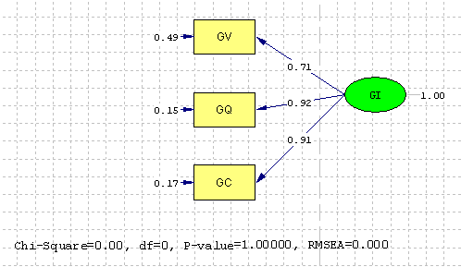
  - Overall Model: After obtaining higher-order factor loadings from separate analyses, these values have been fixed in the complete model, and the overall model has been checked. There is only one modification has been made for this model, that is, we allow the 3rd order factor, the General Intelligence to load on Perceptual Speed factor. Before doing that, the model fit is poorer than current one. This is consistent with previous EFA result, that this factor “did not cluster neatly with any of these second-order clusters” (p.116, Marshalek, et al). Generally speaking, the overall model yields acceptable results. Both Goodness-of-fit statistics and residuals are indicative of model fit.
- Degrees of Freedom = 589
- Minimum Fit Function Chi-Square = 849.08 (P = )
- Root Mean Square Error of Approximation (RMSEA) = 0.04
- Root Mean Square Residual (RMR) = 0.053
- Goodness of Fit Index (GFI) = 0.85
- Normed Fit Index (NFI) = 0.86
- Non-Normed Fit Index (NNFI) = 0.94
- Comparative Fit Index (CFI) = 0.95

Figure 9: Summary Statistics for Fitted Residuals
(1) Stem-leaf of Standardized Residuals
- 3|4
- 2|986666555
- 2|4332221000000
- 1|9999998888777777766666555555
- 1|4444433333333322222222221111111111111111111000000000000000
- 0|999999999999999999998888888888888887777777777777777777766666666666666666+26
- 0|444444444444444444444443333333333333333332222222222222222222222222222222+69
0|111111111111111111111111111111111112222222222222222222222222222222333333+53
0|555555555555555555555555555566666666666666667777777777777777777777888888+35
1|0000000000000011111111111111122222222222222223333333333444444444444
1|55555555566666666666677778888889
2|0001111222333444444
2|589
3|14
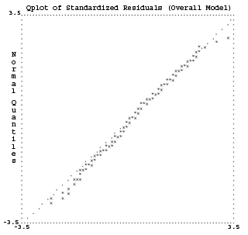

Figure 8: Path Diagraph for the Overall Factor Model
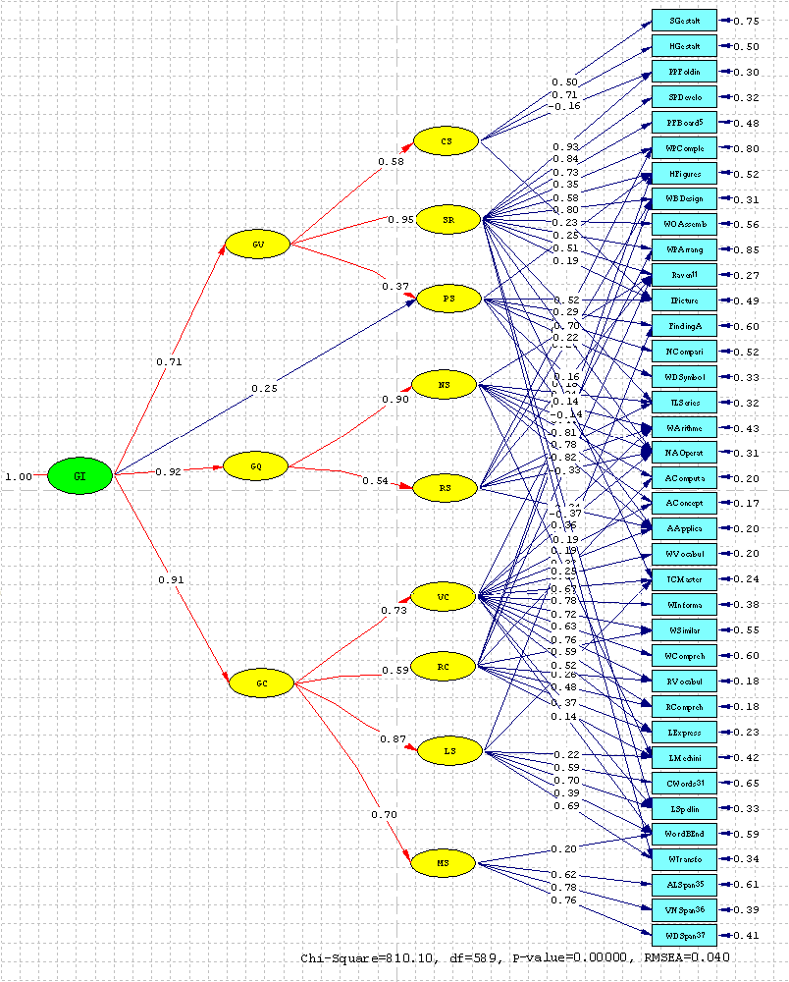
- The only free parameter for the higher-order is Gamma 3 1, from General Intelligence to Perceptual Speed. Other Gamma and Beta parameters are fixed values obtained from previous models.
- Schmid-Leiman Solution: Factor loading matrices obtained from LISREL CFA were used in SAS to generate Schmid-Leiman solution (See Appendix 3). Comparing this solution to the solution in article, generally speaking, the pattern matrix is consistent with the article matrix. As indicated in the article, complex tests are expected to be highly correlated with the 3rd order factor. And I compare the magnitude of the factor weights yielded by Schmid-Leiman procedures and by Wherry’ s procedures (used in the article), the order of the tests in terms of 3rd-order factor loading weight are similar in 2 orthogonal hierarchical matrices.

Table 6: General Intelligence Factor Loading Weight Comparison
Test | 3rd -Order Factor loading weight | Order in My Results | Order in Article Results | Complexity Order in Article
Arithmetic_Concepts | 0.78 | 1 | 1 | 1
Arithmetic_Computation | 0.77 | 2 | 5 | 2
Arithmetic_Application | 0.74 | 3 | 6 | 3
Raven | 0.74 | 4 | 2 | 4
Word_Transformations | 0.68 | 5 | 10 | 14
Thurstone_Letter_Series | 0.68 | 6 | 8 | 11
Reading_Comprehension | 0.67 | 7 | 7 | 5
Terman_Concept_Mastery | 0.66 | 8 | 4 | 10
Reading_Vocabulary | 0.66 | 9 | 11 | 6
Language_Expression | 0.65 | 10 | 9 | 7
Necessary_Arithmetic_Operations | 0.63 | 11 | 3 | 12
Language_Mechinical | 0.63 | 12 | 18 | 8
WAIS_Vocabulary | 0.59 | 13 | 13 | 13
WAIS_Arithmetic | 0.57 | 14 | 17 | 19
Surface_Development | 0.56 | 15 | 21 | 14
Paper_Folding | 0.55 | 16 | 12 | 15
Language_Spelling | 0.54 | 17 | 26 | 9
Word_Beginning_Ending | 0.54 | 18 | 22 | 24
WAIS_Information | 0.53 | 19 | 19 | 18
WAIS_Block_Design | 0.51 | 20 | 16 | 17
Visual_Number_Span | 0.50 | 21 | 28 | 26
Hidden_Figures | 0.50 | 22 | 15 | 20
Paper_Form_Board | 0.49 | 23 | 12 | 23
WAIS_Digit_Span | 0.48 | 24 | 34 | 27
Camouflage_Words | 0.48 | 25 | 25 | 28
WAIS_Object_Assembly | 0.45 | 26 | 24 | 25
WAIS_Comprehension | 0.42 | 27 | 29 | 21
Auditory_Letter_Span | 0.40 | 28 | 35 | 33
WAIS_Similarities | 0.38 | 29 | 31 | 22
Identical_Pictures | 0.37 | 30 | 20 | 29
Finding_As | 0.35 | 31 | 30 | 34
WAIS_Picture_Completion | 0.34 | 32 | 33 | 31
WAIS_Picture_Arrangement | 0.30 | 33 | 23 | 30
Harshman_Gestalt | 0.29 | 34 | 36 | 36
WAIS_Digit_Symbol | 0.22 | 35 | 27 | 32
Street_Gestalt | 0.20 | 36 | 37 | 37
Number_Comparison | 0.18 | 37 | 32 | 35

However, we do find some discrepancies in the loading matrix. This is not surprising since the old model has been modified in this project. Also the communalities for the tests are lower in my results than the article results. This may be caused by the method I used—in EFA, even with rotation, the simple structure solution can not be as neat as what we obtained from the CFA; with more trivial values in the EFA solution, the sum of square of factor loadings should be higher than the CFA solution, in which many loadings are fixed to be zero.

In addition, there are some differences in the amount of total variance explained by these factors as shown in the table below. Big gap exists for Visualization, Quantitative, Verbal, and Reading Comprehension. But if we sum % of variance explained by all verbal factors, the results in 2 solutions are very close (25 vs. 24). Also if we sum % of variance explained by all Visualization and Quantitative factors, the results again are similar (26 vs. 25). Pooling Visualization and Quantitative factors together is justified since “the Gf factor combines tests thought to require analytic reasoning with tests of spatial visualization. Such tests often correlate highly and are not distinguished in orthogonal factor analyses…..The combined label, Gfv, is thus sometimes used” (Marshalek, et al).

Table 7: Total Variance Explained by Each Factor Comparison
 | % of Total Variance in My Results | % of Total Variance in Article Results
General Intelligence | 49 | 51
Visualization | 10 | 6
Quantitative | 1 | 6
Verbal | 5 | 10
Closure Speed | 3 | 1
Spatial Relationship | 2 | 3
Perceptual Speed | 7 | 6
Reasoning with Symbols | 2 | 1
Number Skills | 2 | 1
Reading Comprehension | 11 | 4
Verbal Comprehension | 3 | 3
Language Skills | 2 | 3
Memory Span | 4 | 4
Total | 100 | 100
- In the article, total variance is 69%, so transformation (percent divided by 69) is done to compute the percent of extracted variance explained by the factor.

In Summary, the CFA approach and Schmid-Leiman technique produce comparable results. The model specifications, obviously, still need further check by the experts in the field, especially for the Quantitative factor load tests, which are associated with most of the larger standardized residuals. In addition, more efforts should be spent on fitting the overall model to the data, since using fixed values for the higher-order factor loadings causes some of the diagonal of the Covariance Matrix of ETA and KSI, and of the Fitted Covariance Matrix to have value other than 1 (e.g. 0.99 and 1.01) . Furthermore, EFA, although not appropriate for producing such a complicated model, is very informative in the initial analysis stage.
Appendix 1: Orthogonal Hierarchical Matrix (EFA: Maximum Likelihood Extraction) Using Schmid-Leiman Procedure
SAS MLE 9-4-1 | G1(3rd) | Q + C | V + Q | PS | V | VC+RC | SR | NS+RS | PS | MS | CS | LS | RC | SR+RS
Street_Gestalt | 0.20 |  | 0.15 |  | 0.33 |  |  |  |  |  | 0.21
Harshman_Gestalt | 0.20 |  | 0.21 |  | 0.42 |  | 0.11 |  |  |  | 0.24
WAIS_Picture_Completio | 0.29 |  | 0.23 |  | 0.18 | 0.10 | 0.13 |  |  |  |  |  |  | 0.17
Paper_Folding | 0.52 |  | 0.60 |  |  |  | 0.39
Surface_Development | 0.52 |  | 0.53 |  | 0.14 |  | 0.31
Paper_Form_Board | 0.43 |  | 0.48 |  | 0.19 |  | 0.29 |  |  |  |  |  |  | -0.15
Hidden_Figures | 0.48 |  | 0.38 | 0.17 | 0.13 |  | 0.24 |  |  |  |  |  | 0.12
WAIS_Block_Design | 0.46 |  | 0.54 |  | 0.16 | 0.11 | 0.29 |  |  |  |  |  | -0.15 | 0.16
WAIS_Object_Assembly | 0.38 |  | 0.45 |  | 0.19 |  | 0.28
Identical_Pictures | 0.41 |  | 0.23 | 0.47 | 0.20 |  | 0.12 |  | 0.26
Finding_As | 0.41 |  |  | 0.43 |  |  |  |  | 0.24 |  |  | 0.13
Number_Comparison | 0.38 |  |  | 0.53 |  |  |  |  | 0.30
WAIS_Digit_Symbol | 0.41 |  |  | 0.65 | -0.19 |  |  |  | 0.37
Thurstone_Letter_Series | 0.57 | 0.16 | 0.32 |  |  |  | 0.11 | 0.27 |  |  |  |  |  | 0.47
Raven | 0.64 | 0.13 | 0.41 | 0.10 |  |  | 0.24 | 0.16 |  |  |  |  | 0.21 | 0.19
WAIS_Arithmetic | 0.56 | 0.24 | 0.25 |  | -0.15 | 0.24 |  | 0.28 |  |  |  |  | -0.14 | -0.15
Necessary_Arithmetic_Operations | 0.65 | 0.21 | 0.31 |  |  | 0.15 | 0.11 | 0.26 |  |  |  |  |  | -0.21
Word_Transformations | 0.63 | 0.24 | 0.16 |  | 0.11 |  |  |  |  |  |  | 0.24
Arithmetic_Computation | 0.64 | 0.25 | 0.19 | 0.15 |  |  |  | 0.68 |  |  |  |  | 0.11 | 0.15
Arithmetic_Concepts | 0.68 | 0.26 | 0.28 |  |  |  |  | 0.57 |  |  |  |  |  | 0.13
Arithmetic_Application | 0.64 | 0.30 | 0.24 |  |  | 0.12 |  | 0.61
WAIS_Vocabulary | 0.58 | 0.33 | 0.12 |  |  | 0.62 |  |  |  |  |  |  | 0.10
Terman_Concept_Mastery | 0.67 | 0.32 | 0.23 |  |  | 0.41 |  |  |  |  |  | 0.14
WAIS_Information | 0.52 | 0.29 | 0.15 | -0.14 |  | 0.53
WAIS_Similarities | 0.42 | 0.18 | 0.22 | -0.13 |  | 0.44
WAIS_Comprehension | 0.42 | 0.18 | 0.18 |  |  | 0.44
Reading_Vocabulary | 0.62 | 0.38 |  |  | 0.15 | 0.50 |  |  |  |  |  |  | 0.31
Reading_Comprehension | 0.65 | 0.36 | 0.10 |  |  | 0.31 |  |  |  |  |  |  | 0.43
Language_Expression | 0.63 | 0.35 |  |  |  | 0.26 |  |  |  |  |  |  | 0.40
Camouflage_Words | 0.45 | 0.22 |  | 0.16 | 0.22 |  |  |  |  | 0.13 | 0.11 | 0.24
Language_Mechinical | 0.55 | 0.29 |  | 0.17 |  |  |  | 0.30 |  | 0.11 |  | 0.06 | 0.28
Language_Spelling | 0.56 | 0.42 | -0.13 |  |  | 0.19 |  |  |  |  |  | 0.38
Word_Beginning_Ending | 0.49 | 0.25 |  |  | 0.13 | 0.14 |  |  |  | 0.23 |  | 0.13
Auditory_Letter_Span | 0.37 | 0.21 |  | 0.11 |  |  |  |  |  | 0.51 |  |  |  | -0.14
Visual_Number_Span | 0.48 | 0.21 |  | 0.13 |  |  |  |  |  | 0.58 |  |  |  | 0.11
WAIS_Digit_Span | 0.42 | 0.22 |  |  |  |  |  |  |  | 0.68
WAIS_Picture_Arrangement | 0.27 |  | 0.20 |  |  | 0.12 | 0.12
- Loading smaller than + 0.10 not shown

Appendix 2: Nine First-Order Factor Pattern Matrix (EFA: Maximum Likelihood Extraction)
SAS | VC | SR | NS | PS | MS | CS | LS | RC | ?
Street_Gestalt | 0.02 | 0.15 | 0.12 | -0.08 | -0.03 | 0.40 | 0.10 | -0.06 | -0.02
Harshman_Gestalt | 0.02 | 0.27 | 0.07 | -0.06 | -0.01 | 0.47 | -0.03 |  | -0.01
Paper_Folding | -0.01 | 0.94 | -0.05 | -0.13 | 0.05 | -0.15 | -0.01 | 0.06 | -0.05
Surface_Development | -0.05 | 0.75 | 0.09 | -0.01 | 0.08 | 0.08 | -0.04 | -0.02 | 0.08
Paper_Form_Board | -0.03 | 0.70 | 0.06 | 0.06 | 0.01 | 0.16 | -0.17 | 0.09 | -0.15
WAIS_Picture_Completion | 0.15 | 0.31 | -0.03 | 0.07 | -0.09 | 0.11 | -0.03 | 0.07 | 0.17
Hidden_Figures | 0.03 | 0.59 | -0.03 | 0.17 | -0.06 | 0.05 | 0.01 | 0.14 | -0.06
WAIS_Block_Design | 0.16 | 0.70 | -0.01 | 0.03 | 0.04 | 0.10 | -0.09 | -0.19 | 0.17
WAIS_Object_Assembly | 0.02 | 0.69 | -0.13 |  | -0.01 | 0.13 | 0.10 | -0.12 | 0.06
Identical_Pictures |  | 0.30 | -0.03 | 0.58 | -0.02 | 0.18 | -0.07 | -0.01
Finding_As | 0.02 | 0.02 | -0.05 | 0.53 | -0.05 | 0.02 | 0.22 | 0.06 | 0.05
Number_Comparison | -0.04 | -0.08 | 0.05 | 0.68 | 0.05 | -0.03 | 0.12 | -0.04 | -0.08
WAIS_Digit_Symbol | 0.04 |  | 0.07 | 0.83 |  | -0.23 | -0.08 | -0.03 | 0.02
WAIS_Picture_Arrangement | 0.18 | 0.28 | -0.03 | -0.02 | -0.11 | 0.02 | 0.06 | 0.06 | 0.04
Raven | -0.06 | 0.59 | 0.21 | -0.02 | -0.03 | -0.10 | 0.08 | 0.26 | 0.20
Thurstone_Letter_Series | 0.13 | 0.27 | 0.35 | -0.01 |  | -0.05 | 0.02 | 0.05 | 0.48
WAIS_Arithmetic | 0.35 | 0.12 | 0.37 | -0.01 | 0.05 | -0.08 | 0.12 | -0.17 | -0.15
Necessary_Arithmetic_Operations | 0.22 | 0.28 | 0.34 | 0.14 | 0.02 | -0.05 | 0.03 | 0.03 | -0.22
Arithmetic_Computation | -0.02 | -0.08 | 0.90 | 0.11 | 0.02 | 0.02 | -0.11 | 0.13 | 0.16
Arithmetic_Concepts | 0.10 | 0.09 | 0.76 | 0.01 | -0.03 | 0.04 | -0.01 | 0.07 | 0.13
Arithmetic_Application | 0.18 | -0.02 | 0.81 | -0.10 | 0.04 | 0.16 | 0.02 | -0.05 | -0.05
WAIS_Vocabulary | 0.90 | -0.07 | -0.05 | 0.05 | 0.06 |  | -0.03 | 0.12 | 0.03
Terman_Concept_Mastery | 0.59 | 0.18 | 0.08 | -0.02 | -0.06 | -0.02 | 0.24 | 0.03
WAIS_Information | 0.76 | -0.02 | 0.03 | -0.02 | -0.03 | 0.06 | 0.06 |  | 0.10
WAIS_Similarities | 0.64 | 0.10 | 0.08 | -0.01 | -0.05 | 0.01 | -0.04 | -0.10 | -0.01
WAIS_Comprehension | 0.63 | 0.10 | -0.06 | 0.03 | 0.07 | -0.05 | -0.12 | 0.04 | 0.08
Reading_Vocabulary | 0.73 | -0.06 | 0.03 | -0.02 | 0.05 | 0.11 | -0.01 | 0.39 | -0.09
Reading_Comprehension | 0.44 | 0.10 | 0.05 | -0.04 | -0.01 | -0.11 | 0.10 | 0.53 | -0.02
Language_Expression | 0.37 | 0.02 | 0.09 | -0.01 | 0.07 | -0.02 | 0.08 | 0.50 | 0.09
Language_Mechinical | -0.02 | -0.12 | 0.39 | 0.12 | 0.13 | 0.05 | 0.11 | 0.35 | 0.01
Camouflage_Words | -0.06 | 0.11 | -0.08 | 0.13 | 0.16 | 0.21 | 0.41 | 0.11 | 0.02
Language_Spelling | 0.27 | -0.21 | 0.04 | 0.08 | -0.04 | -0.06 | 0.66 | 0.12 | -0.03
Word_Beginning_Ending | 0.20 | 0.06 | -0.09 | 0.09 | 0.27 | 0.11 | 0.23 | 0.09 | 0.03
Word_Transformations | 0.08 | 0.21 | 0.03 | 0.20 | 0.11 | 0.10 | 0.42 | -0.04 | 0.04
Auditory_Letter_Span | -0.09 | -0.06 | 0.08 | 0.03 | 0.61 | 0.04 | 0.03 | 0.13 | -0.14
Visual_Number_Span |  | 0.02 | 0.08 | 0.05 | 0.69 | -0.07 | 0.06 | -0.08 | 0.11
WAIS_Digit_Span | 0.13 | 0.02 | -0.06 | -0.06 | 0.80 | -0.05 | -0.08 | 0.04 | -0.01

Appendix 3: Orthogonal Hierarchical Matrix Produced by Transforming Factor Structure Matrices (CFA: ML Extraction) Using Schmid-Leiman Procedure
 | G1(3rd) | F1(2nd) | F2(2nd) | F3(2nd) | Factor1 | Factor2 | Factor3 | Factor4 | Factor5 | Factor6 | Factor7 | Factor8 | Factor9 | H total
Street_Gestalt | 0.20 | 0.20 |  |  | 0.40 |  |  |  |  |  |  |  |  | 0.24
Harshman_Gestalt | 0.29 | 0.29 |  |  | 0.57 |  |  |  |  |  |  |  |  | 0.49
Paper_Folding | 0.55 | 0.55 |  |  | -0.16 | 0.29 |  |  |  |  |  |  |  | 0.71
Surface_Development | 0.56 | 0.56 |  |  |  | 0.26 |  |  |  |  |  |  |  | 0.69
Paper_Form_Board | 0.49 | 0.48 |  |  |  | 0.23 |  |  |  |  |  |  |  | 0.52
WAIS_Picture_Completion | 0.34 | 0.23 | 0.04 |  |  | 0.11 |  |  |  |  |  |  | 0.18 | 0.22
Hidden_Figures | 0.50 | 0.43 |  | 0.03 |  | 0.18 | 0.14 |  |  | 0.10 |  |  |  | 0.49
WAIS_Block_Design | 0.51 | 0.52 | 0.05 | -0.06 |  | 0.24 |  |  |  | -0.21 |  |  | 0.21 | 0.69
WAIS_Object_Assembly | 0.45 | 0.44 |  |  |  | 0.21 |  |  |  |  |  |  |  | 0.44
WAIS_Picture_Arrangement | 0.30 | 0.16 |  | 0.06 |  | 0.08 |  |  | 0.14 |  |  |  |  | 0.14
Raven | 0.74 | 0.36 | 0.11 | 0.05 |  | 0.17 |  | 0.09 |  | 0.18 |  |  | 0.14 | 0.77
Identical_Pictures | 0.37 | 0.37 |  |  | 0.24 | 0.05 | 0.50 |  |  |  |  |  |  | 0.58
Finding_As | 0.35 | 0.11 |  | 0.11 |  |  | 0.39 |  |  |  | 0.15 |  |  | 0.32
Number_Comparison | 0.18 | 0.18 |  |  |  |  | 0.65 |  |  |  |  |  |  | 0.49
WAIS_Digit_Symbol | 0.22 | 0.21 |  |  |  |  | 0.76 |  |  |  |  |  |  | 0.67
Thurstone_Letter_Series | 0.68 | 0.22 | 0.19 |  |  | 0.10 |  | 0.14 |  |  |  |  | 0.30 | 0.66
WAIS_Arithmetic | 0.57 |  | 0.07 | 0.18 |  |  |  | 0.20 | 0.41 |  |  |  | -0.35 | 0.69
Necessary_Arithmetic_Operations | 0.63 | 0.16 | 0.07 | 0.14 |  | 0.05 | 0.18 | 0.17 | 0.32 |  |  |  | -0.30 | 0.71
Arithmetic_Computation | 0.77 |  | 0.30 | 0.03 |  |  |  | 0.37 |  | 0.11 |  |  |  | 0.82
Arithmetic_Concepts | 0.78 |  | 0.28 | 0.06 |  |  |  | 0.34 | 0.14 |  |  |  |  | 0.82
Arithmetic_Application | 0.74 | -0.04 | 0.23 | 0.12 |  |  | -0.13 | 0.35 | 0.26 |  |  |  | -0.23 | 0.88
WAIS_Vocabulary | 0.59 |  |  | 0.27 |  |  |  |  | 0.61 |  |  |  |  | 0.79
Terman_Concept_Mastery | 0.66 | 0.08 |  | 0.26 |  | 0.04 |  |  | 0.47 |  | 0.08 |  |  | 0.73
WAIS_Information | 0.53 |  |  | 0.24 |  |  |  |  | 0.54 |  |  |  |  | 0.62
WAIS_Similarities | 0.38 |  |  | 0.17 |  |  |  |  | 0.49 | -0.15 |  |  |  | 0.44
WAIS_Comprehension | 0.42 |  |  | 0.19 |  |  |  |  | 0.43 |  |  |  |  | 0.40
Reading_Vocabulary | 0.66 |  |  | 0.30 |  |  |  |  | 0.53 | 0.21 |  |  |  | 0.85
Reading_Comprehension | 0.67 |  |  | 0.31 |  |  |  |  | 0.43 | 0.38 |  |  |  | 0.87
Language_Expression | 0.65 |  |  | 0.29 |  |  |  |  | 0.38 | 0.42 |  |  |  | 0.82
Language_Mechinical | 0.63 |  |  | 0.18 |  |  |  | 0.12 |  | 0.33 | 0.11 |  |  | 0.57
Camouflage_Words | 0.48 |  |  | 0.22 |  |  |  |  |  |  | 0.30 |  |  | 0.36
Language_Spelling | 0.54 | -0.25 |  | 0.36 |  | -0.12 |  |  | 0.27 |  | 0.34 |  |  | 0.69
Word_Beginning_Ending | 0.54 |  |  | 0.25 |  |  |  |  | 0.10 |  | 0.20 | 0.13 |  | 0.42
Word_Transformations | 0.68 | 0.12 |  | 0.25 |  | 0.06 |  |  |  |  | 0.35 |  |  | 0.66
Auditory_Letter_Span | 0.40 |  |  | 0.18 |  |  |  |  |  |  |  | 0.44 |  | 0.38
Visual_Number_Span | 0.50 |  |  | 0.23 |  |  |  |  |  |  |  | 0.56 |  | 0.62
WAIS_Digit_Span | 0.48 |  |  | 0.22 |  |  |  |  |  |  |  | 0.54 |  | 0.58
Sum of Square Loading | 0.488 | 0.101 | 0.013 | 0.05 | 0.026 | 0.019 | 0.068 | 0.022 | 0.109 | 0.027 | 0.018 | 0.038 | 0.021
Percent of Extract Variance  Explained by | 0.488 | 0.165 (Second Order Factor in total) |  |  | 0.347 (Third Order Factor in total)

Appendix 4: Orthogonal Hierarchical Matrix From Marshalek, et al (1983)
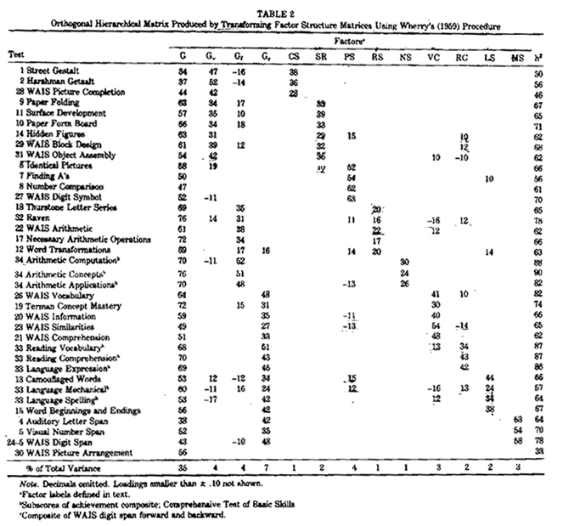

VI. Reference
Kline, R. (2004). Principles and Practice of Structural Equation Modeling, The Guilford Press; 2nd edition
Marshalek, B., Lohman, D.F., & Snow, R.E. (1983). The complexity continuum in the radex and hierarchical models of intelligence. "Intelligence," 7, 107-127.
Wolff, H.-G. & Preising, K. (in press). Exploring item and higher-order factor structure with the Schmid-Leiman Solution: Syntax codes for SPSS and SAS. Behavior Research Methods, Instruments, & Computers.

Schmid, J. & Leiman, J.M. (1957). The development of hierarchical factor solutions. Psychometrika, 22, 53-61.

Yung, Y.F., McLeod, L.D., & Thissen, D. (1999). On the relationship between the higher-order factor model and the hierarchical factor model. Psychometrika, 64, 113-128.

